# Nations Education Score on Standardized Tests

By

Sebastian Benny Chengattu

Semester Project

Arizona State University

Professor: Dr. Clough

IEE 380 FALL 2020 Course# 82188

**Project Objective:**

The following project uses existing data to interpret information and draw conclusions from standardized math test scores across the U.S during a time period of 2009 to 2013. I will be using what I have learned throughout this semester to run statistical data analysis and understand the implications of the findings. Not only will this improve my technical writing skills, but it will provide a sense of how findings are driven in real life scenarios and actions implemented.

**Data Description:**

Standardized tests help educators baseline the status of education for current student, while also providing clues for improving students’ education in the future. The performance in education continuously fluctuates over time, as new methodology and ways of teaching improve. These improvements often result in students performing better when tested on their knowledge for core subjects. In 2009, using reports from *The Nation’s Report Card*, students in 8th grade had to take standardized tests to test their knowledge in 4 core sections: math, reading, science, and writing. It had shown that the math section was the category which a lot of the 8th grade students excelled in. The Nation’s Report Card showed test score averages observed in all 50 states plus the District of Columbia. The math section test is out of 500 points. The total student mean scores in 2009 was 282.42, which was the overall average accounting for 50 states & the District of Columbia. The education board wants to see if in the 4 years after 2009, the new pool of tested 8th graders, assuming incremental changes in the education approach was implemented, would show a greater score. The data below shows the 2013 data. Using hypothesis testing, it will be determined if there is evidence (with $α$ = 0.10) to support that the mean score for the math portion of the test exceeds 282.42. The observations are presented on the table in the next page.

**Data:** 8th Grade MATH Scores referenced by The Nation’s Report Card year 2013:

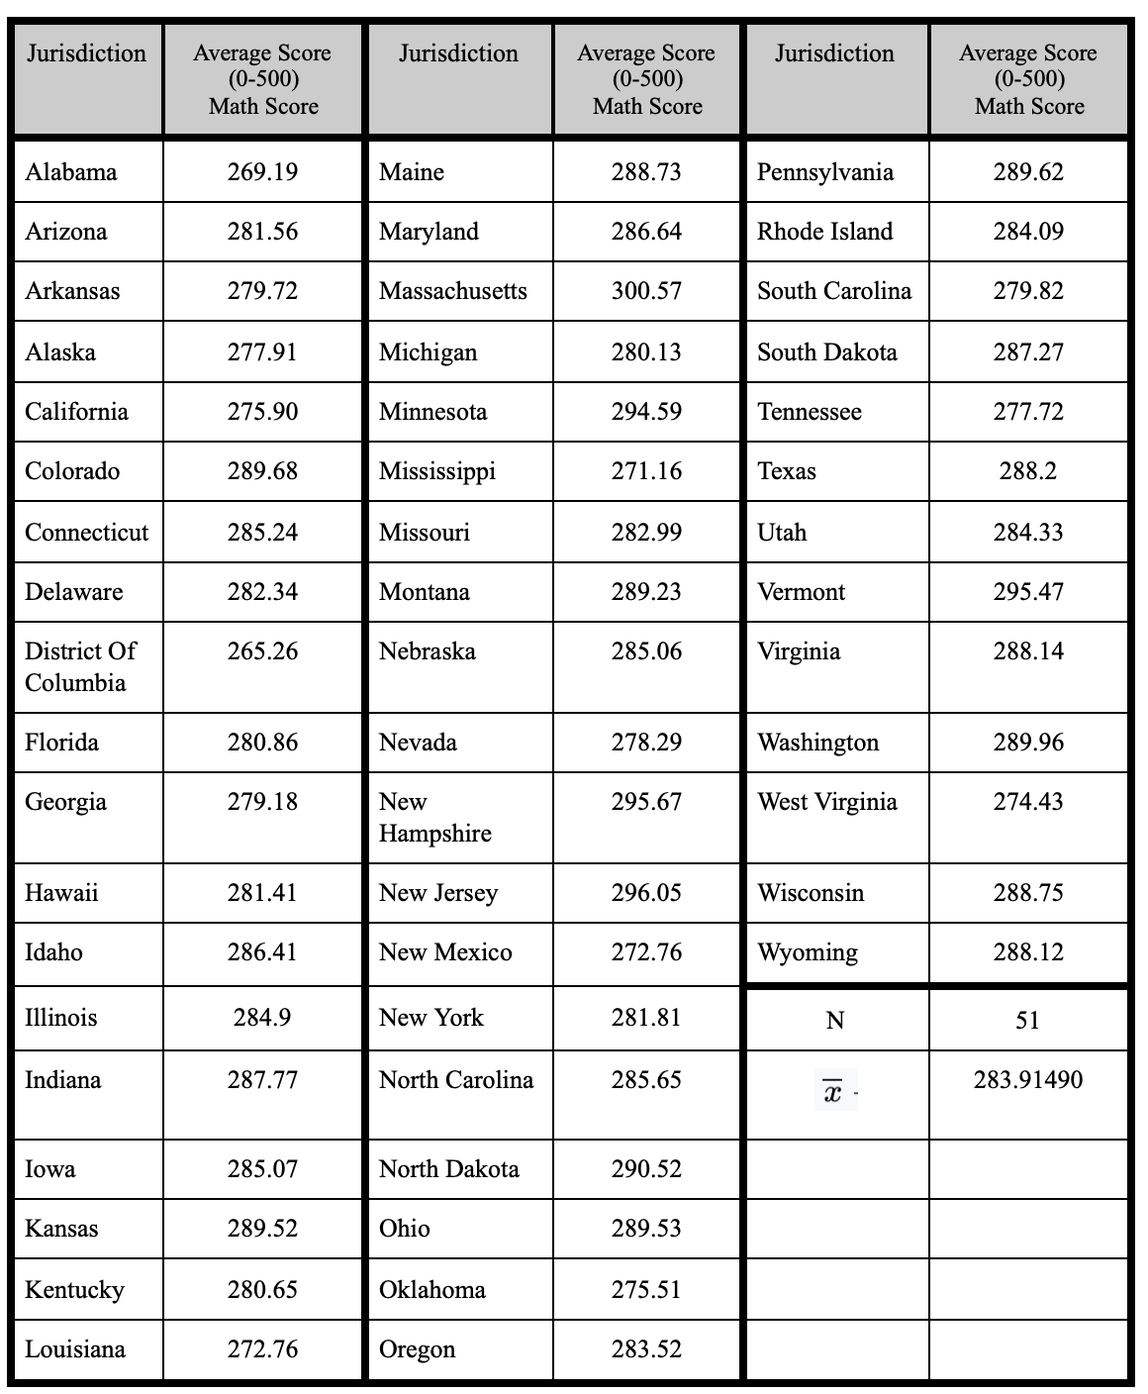

A one- sided alternative hypothesis is appropriate.

~ 8-step procedure for hypothesis testing~

**1. Population parameters of interest: $μ$** .

**2.** **Null Hypothesis:**

H0: = 282.42.

**3. Alternative Hypothesis:**

H1:1 > 282.42.

|  |  |
| --- | --- |
| The *null hypothesis* states that the math test score of students between 2009 to 2013 shows no improvement. This is done by comparing 8th graders in 2009 to 8th graders in 2013 and seeing if their scores had stayed statistically similar. | The *alternative hypothesis* states that the math test score of students between 2009 to 2013 shows improvement. This is done by comparing 8th graders in 2009 to 8th graders in 2013 and seeing if their scores had exceeded the averages observed in 2009. |

**4. Significance level, $α$: $α$** = 0.10

**Variables needed for step 5 and how to get the values:**

| 0 = 282.42 (given) **|** n = 51 | = Σ $\frac{xi }{n}$ = $\frac{14479.66 }{51}$ = 283.91 |

| s = sx= (2nd STAT $→$ MATH $→$ 7: stdDEV) = 7.2310769 (placed the values in a list) |

| ta, n-1= t,50 = (PRGM $→$ Tinverse) = ALPHA=.1 & DF=50 =1.298713694 |

**5. Test Statistic:** t0 = 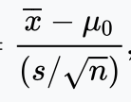

**6. Reject H0 = if:**

*> 0 + ta, n-1s/

* t0 > ta, n-1

* P-value <

**7. Computations:**

t0 == 1.471522778

P value = tcdf(t0 , , n-1) = tcdf(1.4715, 1099 , 50) = 0.0737111502

**8. Conclusion:**

Reject if t0 > ta, n-1…… 1.4715 > 1.2987 $→$ YES! Reject the null.

Reject if P-value < $α$...0.0737 < 0.10 $→$ YES! Reject the null.

**Interpretation:** There is strong evidence to conclude that the mean score of the math portion of the standardized math test exceeds 282.42 between the years of 2009 to 2013.

**Reference**

* “NAEP State Profiles.” *The Nation's Report Card*, www.nationsreportcard.gov/profiles/stateprofile?chort=2.
  + U.S. Department of Education, Institute of Education Sciences, National Center for Education Statistics, National Assessment of Educational Progress (NAEP), 2013 Mathematics Assessment. <https://www.nationsreportcard.gov/profiles/stateprofile?chort=2&sub=MAT&sj=AL&sfj=NP&st=MN&year=2009R3>
  + U.S. Department of Education, Institute of Education Sciences, National Center for Education Statistics, National Assessment of Educational Progress (NAEP), 2009 Mathematics Assessment.

<https://www.nationsreportcard.gov/profiles/stateprofile?chort=2&sub=MAT&sj=AL&sfj=NP&st=MN&year=2013R3>

* *Study.com*, study.com/academy/lesson/reasons-and-purposes-for-standardized-testing.html.

**Closing notes:**

With the data that I had presented it showed multiple sets of data not only targeting 8th graders in that year but also 4th and 12th graders. The data was produced from the website of *nations report card.* The data I had presented removed two points which may have skewed results. The two removed points were Puerto Rico, and DoDEA(Department of Defense Education Activity) as educational reforms or improvements may not influence these data point. One major reason that Puerto Rico was taken out was looking at the various years there were times when the data set from that jurisdiction did not input any data causing my sample size to vary. DoDEA was taken out purely because it was inconsistent with the type of jurisdiction presented compared to US states.

The story description was based on the reading presented from *Study*. As the information correlates well with the data of the *nation's report card.* Average statewide data may have state specific influences and sampling biases. It’s unclear how data was collected. However given this is a government run program, we assume the average state values is a robust number to compare across states. Some of these assumptions could influence the overall hypothesis testing.

The image of the data table was the screenshot of the table presented below, the data was manually inputted meeting the requirements of 50 observations and mean was not given.

2013

|  |  |  |  |  |  |
| --- | --- | --- | --- | --- | --- |
| Jurisdiction | Average Score  (0-500)  Math Score | Jurisdiction | Average Score  (0-500)  Math Score | Jurisdiction | Average Score  (0-500)  Math Score |
| Alabama | 269.19 | Maine | 288.73 | Pennsylvania | 289.62 |
| Arizona | 281.56 | Maryland | 286.64 | Rhode Island | 284.09 |
| Arkansas | 279.72 | Massachusetts | 300.57 | South Carolina | 279.82 |
| Alaska | 277.91 | Michigan | 280.13 | South Dakota | 287.27 |
| California | 275.90 | Minnesota | 294.59 | Tennessee | 277.72 |
| Colorado | 289.68 | Mississippi | 271.16 | Texas | 288.2 |
| Connecticut | 285.24 | Missouri | 282.99 | Utah | 284.33 |
| Delaware | 282.34 | Montana | 289.23 | Vermont | 295.47 |
| District Of Columbia | 265.26 | Nebraska | 285.06 | Virginia | 288.14 |
| Florida | 280.86 | Nevada | 278.29 | Washington | 289.96 |
| Georgia | 279.18 | New Hampshire | 295.67 | West Virginia | 274.43 |
| Hawaii | 281.41 | New Jersey | 296.05 | Wisconsin | 288.75 |
| Idaho | 286.41 | New Mexico | 272.76 | Wyoming | 288.12 |
| Illinois | 284.9 | New York | 281.81 | N | 51 |
| Indiana | 287.77 | North Carolina | 285.65 |  | 283.91490 |
| Iowa | 285.07 | North Dakota | 290.52 |  |  |
| Kansas | 289.52 | Ohio | 289.53 |  |  |
| Kentucky | 280.65 | Oklahoma | 275.51 |  |  |
| Louisiana | 272.76 | Oregon | 283.52 |  |  |

This is continuous data.